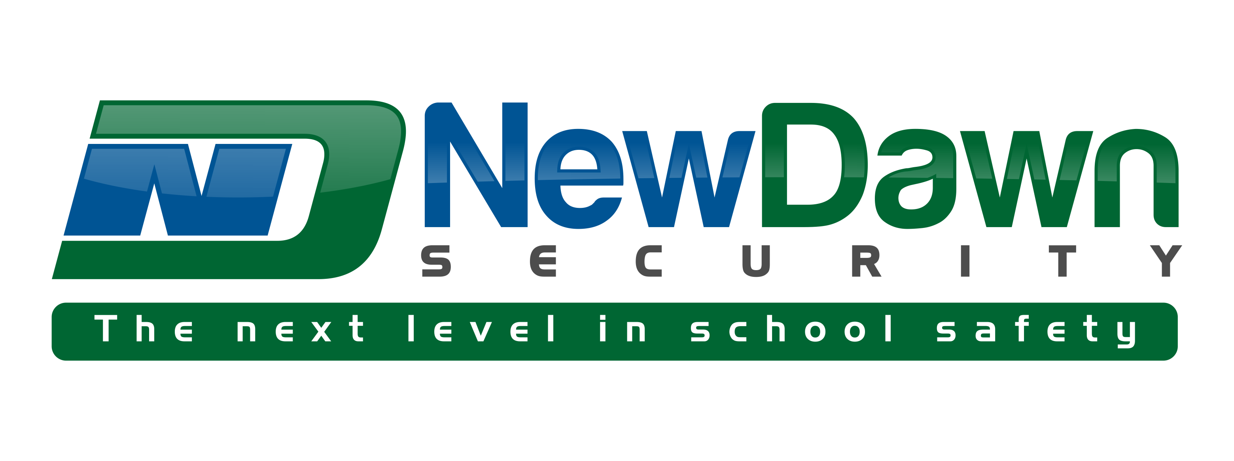

10 SCHOOL SECURITY AND SAFETY CHECKS
TO START THE 2015-2016 SCHOOL YEAR

Regardless if you are anxiously anticipating this next school year or confused on how summer break felt only like a long weekend, the date to see all those smiling faces is fast approaching.

Below is our top ten recommended safety and security “back to school” procedure checklist. If you have any questions, or concerns on whether or not your plans are sufficient please do not hesitate to contact us…and have a great start to the year…

- Floor plans are current and up to date, and classroom’s that have exterior windows or doors are numbered/listed on the floor plan.
- Emergency contact list is updated.
- Check all exit/entry doors to make sure all locking mechanisms/doors themselves are operating properly.
- Review of current “After Crisis Action Plan”
  - Make sure all personnel know their positions and roles
  - Make sure local emergency responders are updated with any changes and with your most recent plans and floor plans
- Supervision locations at your most vulnerable times are staffed properly, and staff know their roles BEFORE school starts
- Security/Safety hardware is inspected and in working order (fire extinguishers, fire alarms, building alarms, AED machines, two way radios, PA/Intercom, etc.…)
- Lockdown, Fire Evacuation, Natural Disaster, and Hazardous Chemical Spill protocols are reviewed for effectiveness, in line with your state law, and are taught to faculty/staff with drills scheduled.
- Faculty/Staff, Parents, and Students are taught how, when, and where to report any type of “out of the ordinary” situation.
- Faculty and staff know visitor policy and procedures, and faculty/staff know how to effectively/safely approach visitors without identification.
- Communication system(s) used to notify the campus and/or contact parent/guardians in case of emergency are tested. In addition, knowledge of a percentage of how many parents receive the “test message” will aid planning.

